# ***Title-page***

NAME: Muhammad Momin Rauf

CMS: 366523

Section : BESE-12-A

Assignment No 1

Submitted to Dr Fahad Satti

Project Name:

***Doctech***

***Overview:***

*The main problem that has been highlighted in this project is to remove the communication gap between patients and the doctors.*

*Following are some problems that have been highlighted while considering this project*

* *The absurd amount of paper file management for keeping the track of patients*
* *The communication gap between doctor and the patient*
* *The misunderstandings due to hand-written prescriptions*
* *Patients have to travel miles even when they have to discuss a small points with the doctors*
* *Patients usually end up losing files provided by the docters and healthcare units, As a result it get’s hard to know which test they have to take again and when, similarly the medicine’s doze and timings*

***What this project solves?***

*This project is designed to provide some pirvilleges and remove all the complications a doctor and his patient have to face:*

***Major modules and problems they address***

* ***Chat***

*This provides a feasibility to patient to book a slot depending on the availability of doctor and can discuss it’s concern and address the issue for which ftf interaction is not important, for which he usually had to travel from miles.*

*Important-but this is only possible if the patient is on treatment with the same doctor and had an examination or checkup before because online treatments before ftf examination is dangerous  
->****Advised by stakeholder ( Harris Hussain- MBBS Student ,Sargodha Medical College, 4th year)***

* ***Appointment Booking:***

*This helps the Patient to book the appointment depending on the availability of the doctor, He can also take appointment of other doctors relevant to his issue, For example, Patient after accident have to go through different medical examination and treatments like Physiotherapy, Psychology treatment etc*

*(After Recommendation by the doctor)*

* ***BP and Sugar Chart***

*It is important for people going through different diseases to have a proper chart to note down their BP and Sugar, Which helps doctors to change the prescriptions*

* ***Test results and reports***

*This will help docters to update the reports on portal giving flexibility to patients not to visit the health center and receive their reports online*

***USER RESEARCH***

*This project has been designed after discussion from stakeholders.*

*Following Stakeholders have been interviewed:*

**Dr Aqsa Ashiq, Final year Student ,Khawaja Muhammad Safdar Medical College sialkot:**

There is dire need of a platform where docter and patient can access the bio data and history of patient eighter through biometric or other way

**Dr Talha Ahmed, Final year Student ,Khawaja Muhammad Safdar Medical College sialkot:**

“Mostly due to large amount of patients waiting outside, Doctors can’t treat the patient in the best possible way which creates lots of queries in minds of patient un addressed and sometimes they forget to share something with the docter so a platform like doctech can help them to ask their queries again without revisit”

***Dr Harris hussain 4th year student MBBS ,Sargodha Medical Colelge,***

**“***Most to of the time patients don’t get what doctors prescribe them, with the help of doctech doctor can update it online if it is not available on market***”**

***Some loop holes discussed by stakeholders while making this project on which we worked.***

***Dr Linta Rauf- Final Year Student MBBS , Khawaja Muhammad Safdar Medical College:***

***“****It is not advisable for patient to monitor their own Sugar and Blood Pressure because there accuracy can really fluctuate if they are not well trained****”***

***For that we will make sure doctor has given permission to that particular patient to access the chart form  
Dr Will give permission only if the patient is trained for it or any other familiy member, Second or if he/she get it checked from nearby clinic***

***Ahmad Zafar Software Engineering Student from nust***

How will you make sure data safety of patient,

**We will use high encryption tools and later with better fundings we can scale it up on blockchain**

**More about this website**

**Site Map**

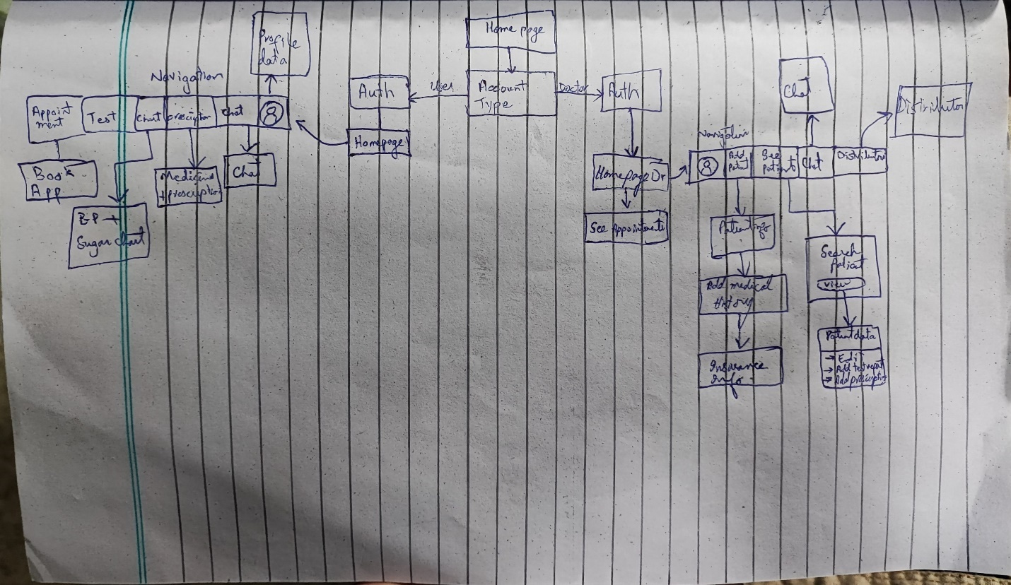

**Sketching during UX designing**

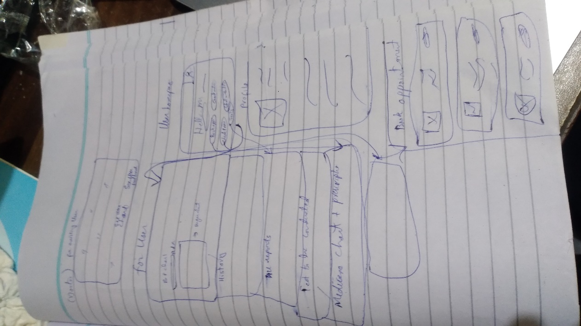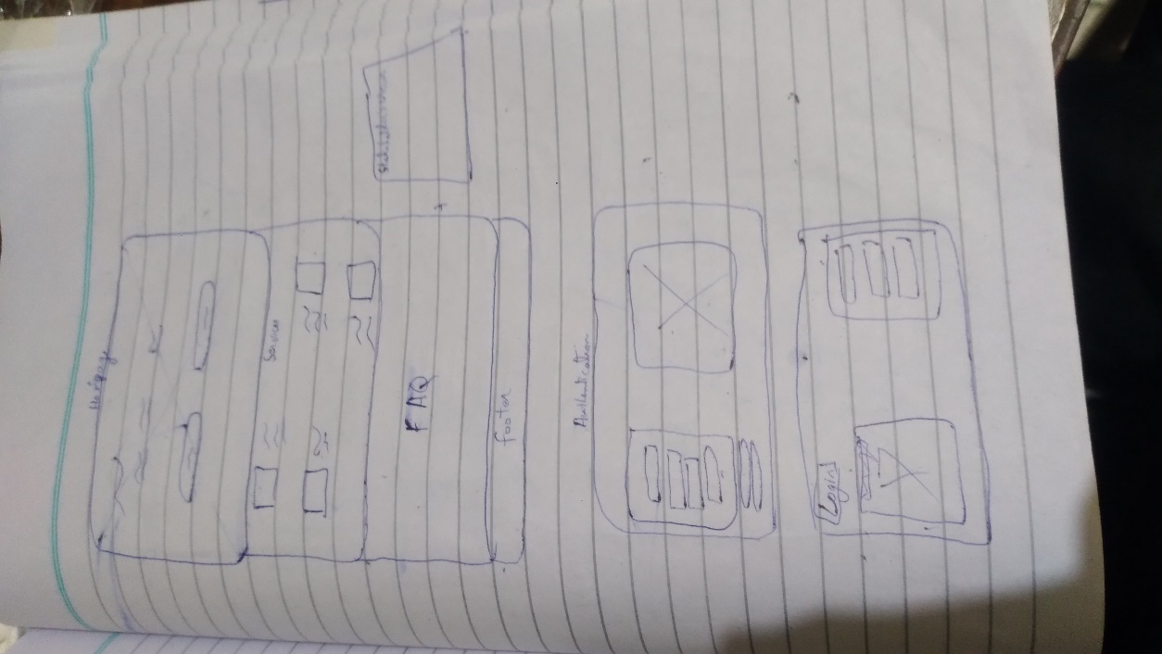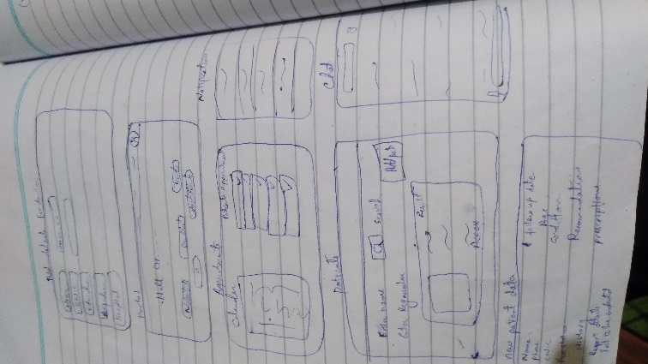

**Total Pages-11**

1. **AddPatient**

1. **Book**

1. **Chat**

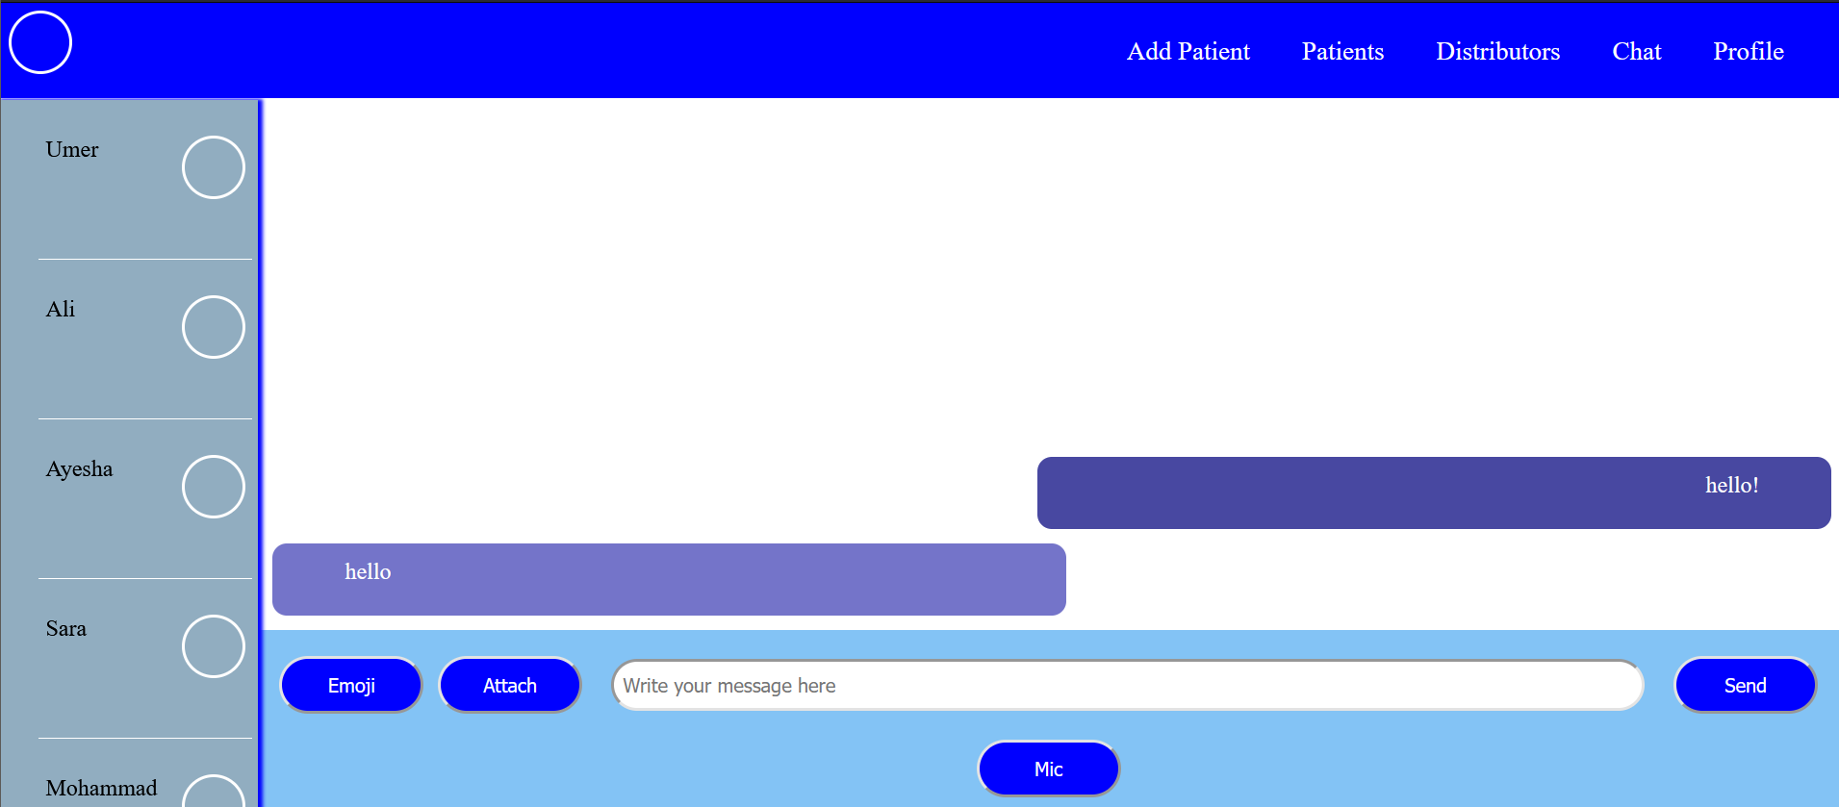

1. **DrHomePage** 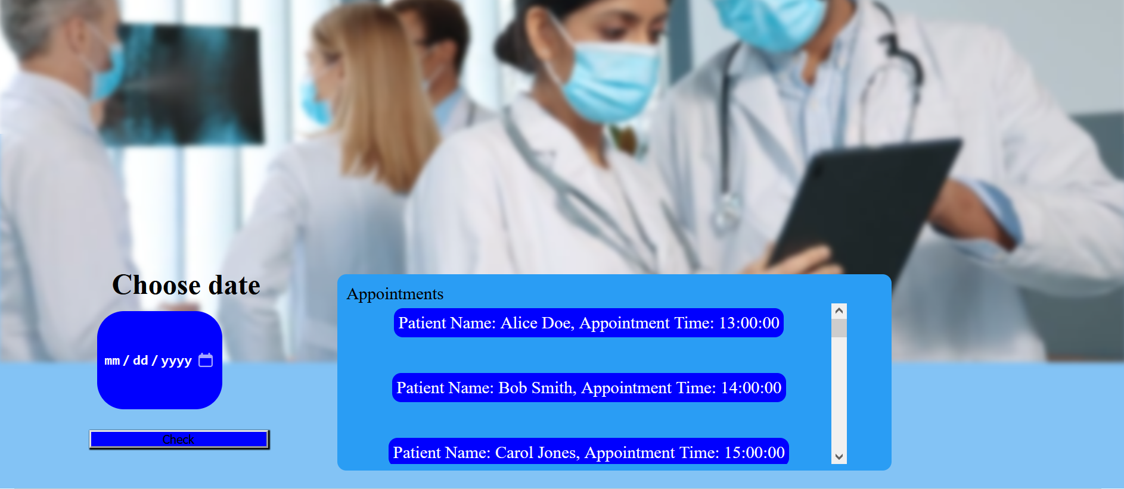
2. **HomePage**

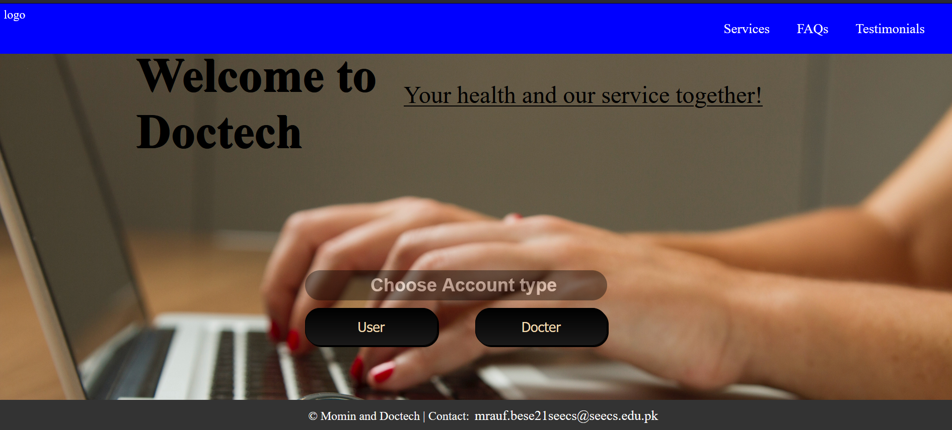

1. **HomePagePatient**

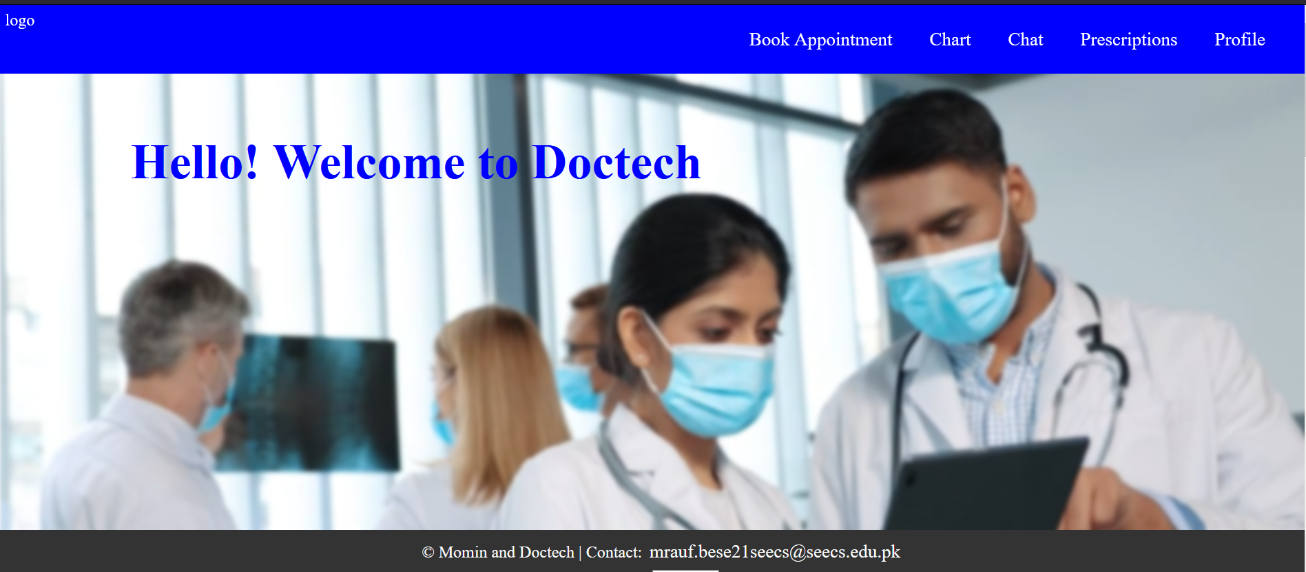

1. **Login** **A screenshot of a computer

   Description automatically generated**
2. **Signup**

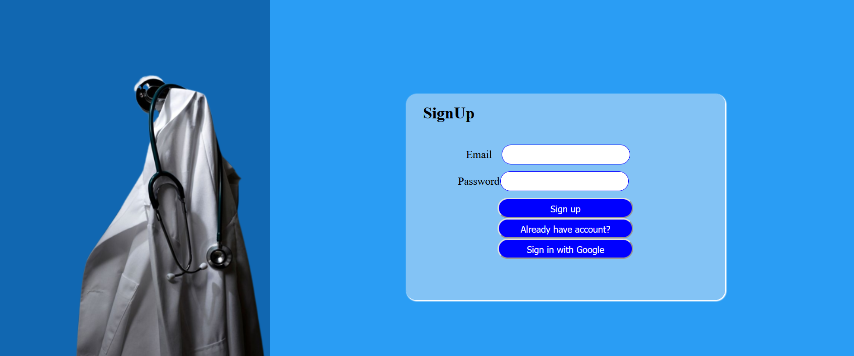

1. **Patient-ProfileA screenshot of a patient profile

   Description automatically generated**
2. **Profile (of Docter)**

1. **Patient**

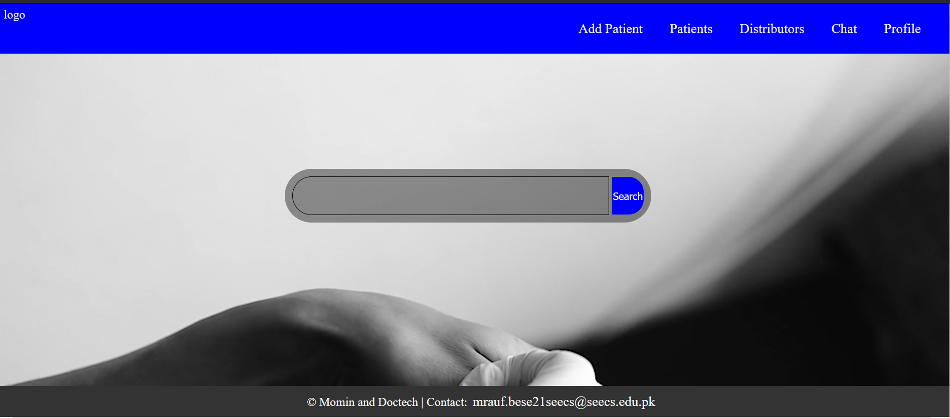

1. **Patient data**

